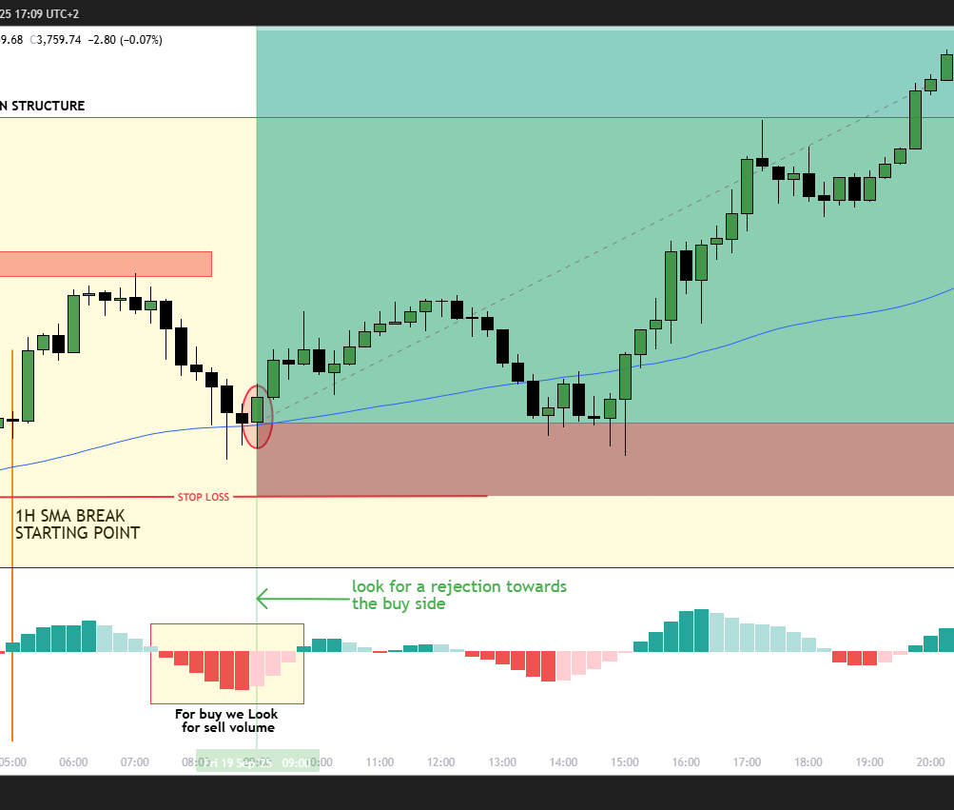

**The Ultimate Trading Blueprint:**

**Feni4Real’s Approach to Consistency**

**52 Trading Academy**

Sbusiso Feni 9/28/25

Feni4Real Trading Plan

### Trading Style s Overview

* + **Primary Instruments**: US30indices and Gold
  + **Time Frame**: 1 Hour (for 1HSMA strategy), 15-Minute (for CIS strategy).
  + **Session Focus**: Focus on **London** and **New York** sessions.
  + **Risk Management**: Risk no more than 1-2% of your account balance per trade.

1. **Trading Strategy Components**

## 1HSMA Strategy (50-SMA on 1-Hour Chart)

#### Identifying the Entry Zone (Label A)

* + **Step 1**: Wait for the price to approach the 50-period Simple Moving Average (SMA) on the 1-Hour chart.
  + **Step 2**: Ensure the current candle is in the same direction as the overall trend (the trend is determined by the position of the price relative to the 50-SMA).

#### Trend Confirmation (Label B)

* + **Step 3**: If the price is above the 50-SMA, the market is in an **uptrend**, and you will look for **buy opportunities**.
  + **Step 4**: If the price is below the 50-SMA, the market is in a **downtrend**, and you will look for **sell opportunities**.
  + **Step 5**: **Do not** take any trade if the price is moving sideways (i.e., it’s stuck around the

SMA without clear direction).

#### Entry Point

* + **Step 6**: For **buy** entries: Look for **bullish engulfing** or other **bullish candlestick patterns** near the 50-SMA.
  + **Step 7**: For **sell** entries: Look for **bearish engulfing** or other **bearish candlestick patterns** near the 50-SMA.
  + **Step 8**: Confirm with **RSI** (relative strength index) or other momentum indicators for additional confirmation.

#### Exit Strategy (Take Profit s Stop Loss)

* + **Step G**: Set **take profit** at a level based on recent **support and resistance** zones, or a risk-to-reward ratio of 2:1.
  + **Step 10**: Set **stop loss** below/above the most recent swing point or 1% of your account balance.

## CIS Strategy (Change in Session)

1. **Conditions for Buying**
   * **Step 1**: Look at the **15-minute chart** for the London session, specifically the 14:45 and 15:15 candles (South African time).
   * **Step 2**: The 14:45 candle must be **bullish** (price should close higher than it opened).
   * **Step 3**: The **entry level** is the closing price of the **15:15 candle**.
   * **Step 4**: The **stop loss** is the **opening price** of the 14:45 candle.
   * **Step 5**: The **take profit** is set at the **previous day's New York session high**.
2. **Conditions for Selling**
   * **Step 1**: For the **selling setup**, focus on the same 15-minute chart for the 14:45 and 15:15 candles.
   * **Step 2**: The 14:45 candle must be **bearish** (price closes lower than it opened).
   * **Step 3**: The **entry level** is the closing price of the **15:15 candle**.
   * **Step 4**: The **stop loss** is the **opening price** of the 14:45 candle.
   * **Step 5**: The **take profit** is set at the **previous day's New York session low**.

### Trade Management

#### Risk Management

* + **Risk per trade**: 10 - 20 % of your account balance.
  + **Stop-loss strategy**: Always set a stop loss according to the entry strategy to protect your capital!!!!.
  + **Position sizing**: Adjust the position size based on your risk percentage.

#### Trade Review

* + **Pre-trade checklist**:

.☐ Have I confirmed the trend on the 1-Hour SMA chart?

.☐ Is the price near a key support/resistance level?

.☐ Have I waited for proper candlestick patterns for confirmation?

.☐ Have I set my stop-loss and take-profit levels?

#### During the trade:

.☐ Is the market respecting the trend?

.☐ If the price moves 50% in favor of the trade, consider moving your stop loss to break-even.

#### Post-trade review:

.☐ Was my risk-to-reward ratio met?

.☐ Did the trade follow my strategy and trade rules?

1. **Psychological Management**
   * **Emotion Control**: Stick to the plan. Do not chase trades or deviate from your strategy, especially after a loss.
   * **Patience**: Wait for the right setups to appear, don’t

force trades.

* + **Confidence**: Trust in your strategy’s 92% win rate with the CIS method and the trend-following 1HSMA strategy.

### Feni4Real Trading Checklist

#### Before the Trade:

.☐ I have reviewed the market sentiment.

.☐ I have identified the trend on the 1-Hour chart using the 50-SMA.

.☐ I have confirmed the entry pattern (candlestick confirmation) on the 15-minute chart.

.☐ I have set a clear stop-loss and take-profit level.

#### During the Trade:

.☐ I am managing the trade, moving the stop to break-even if needed.

.☐ I am not overtrading.

#### After the Trade:

.☐ I have reviewed my trade to learn from mistakes or successes.

.☐ I have updated my trading journal with details of the trade.

### Final Thoughts

This plan combines both trend-following (1HSMA) and session-based breakout setups (CIS). With **proper risk management**, patience, and emotional control, you’re set to consistently follow a structured approach. Stick to the plan, adapt, and adjust based on what works best for you!



# A screenshot of a graphGold 1-Hour SMA Strategy – Full Setup

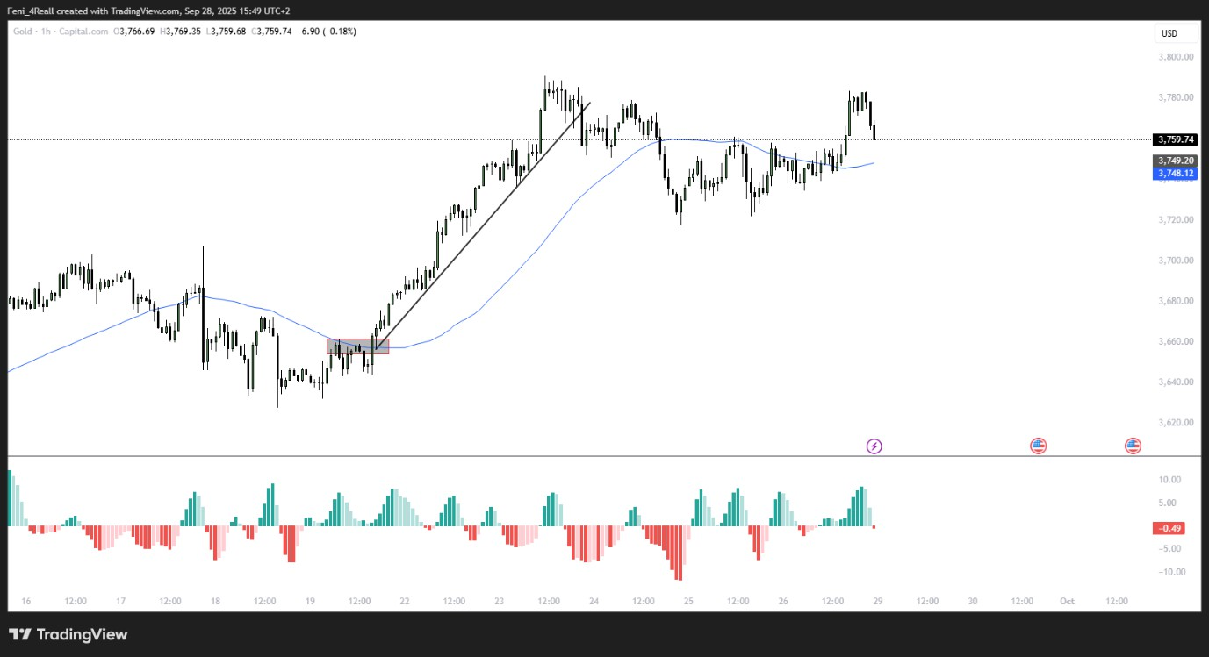

#### Time Frames:

* + **H1 (1-Hour):** 50 SMA → Trend filter C main zone
  + **M15 (15-Minute):** Entry timing C confirmation

**Indicator:** 50-period SMA

#### Step 1 – Identify Trend (H1 SMA) Label C – 50 SMA (H1):

* + Determine trend direction:
    - **Uptrend:** Price above 50 SMA C SMA slopes upward → only consider buy setups
    - **Downtrend:** Price below 50 SMA C SMA slopes downward → only consider sell

setups

**Key Tip:** Only trade **in the direction of H1 trend** to increase success rate.

#### Step 2 – Define Entry Zone (Label A)

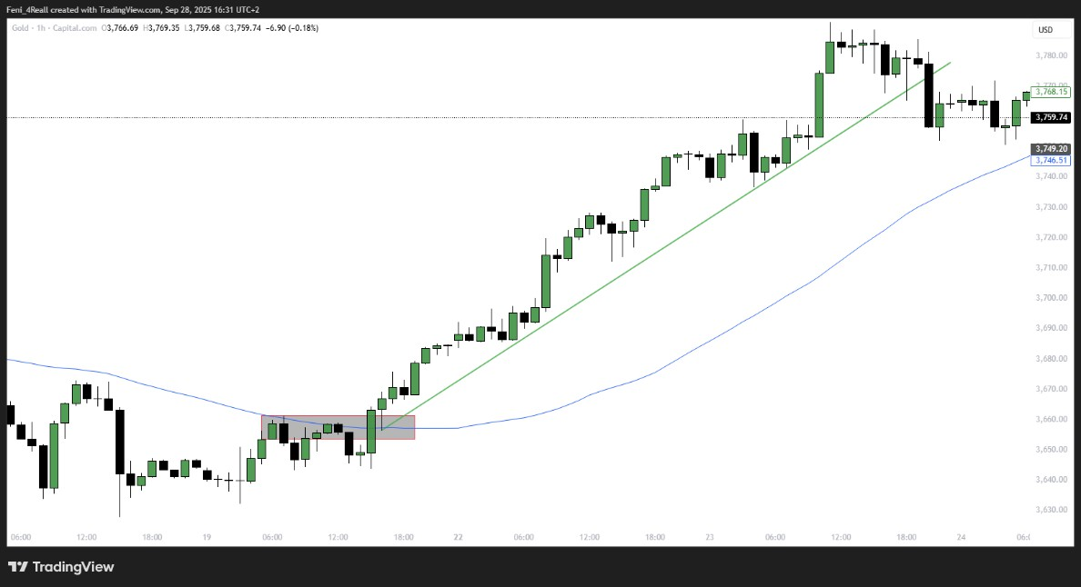

* + **Label A:** Zone where the **price interacts with 50 SMA** on H1.
  + This is the **starting point for trade observation**.

#### Look for price touching, closing near, or slightly piercing the SMA.

* + H1 SMA acts as **dynamic support/resistance** depending on trend direction.

#### Step 3 – Draw Trend Validation Line (Label B)

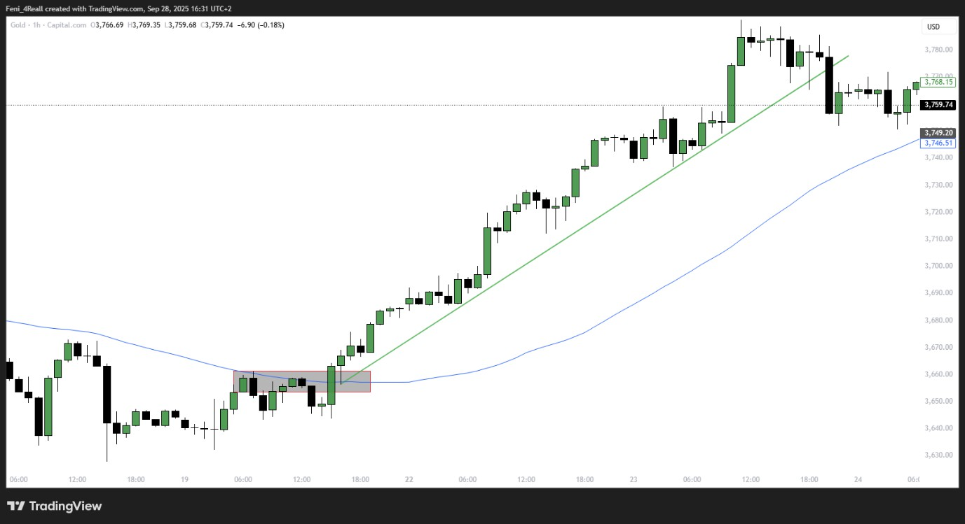

* + Label B = the **trend line** that must **remain unbroken for the trade to stay valid**.
  + Draw line connecting **recent swing highs/lows** in the trend direction.
  + If price breaks this line → trade is **invalid**.

#### Step 4 – Zoom to M15 for Entry

* + Go to **15-minute chart** inside Label A zone.
  + Look for **confirmation patterns** in trend direction:

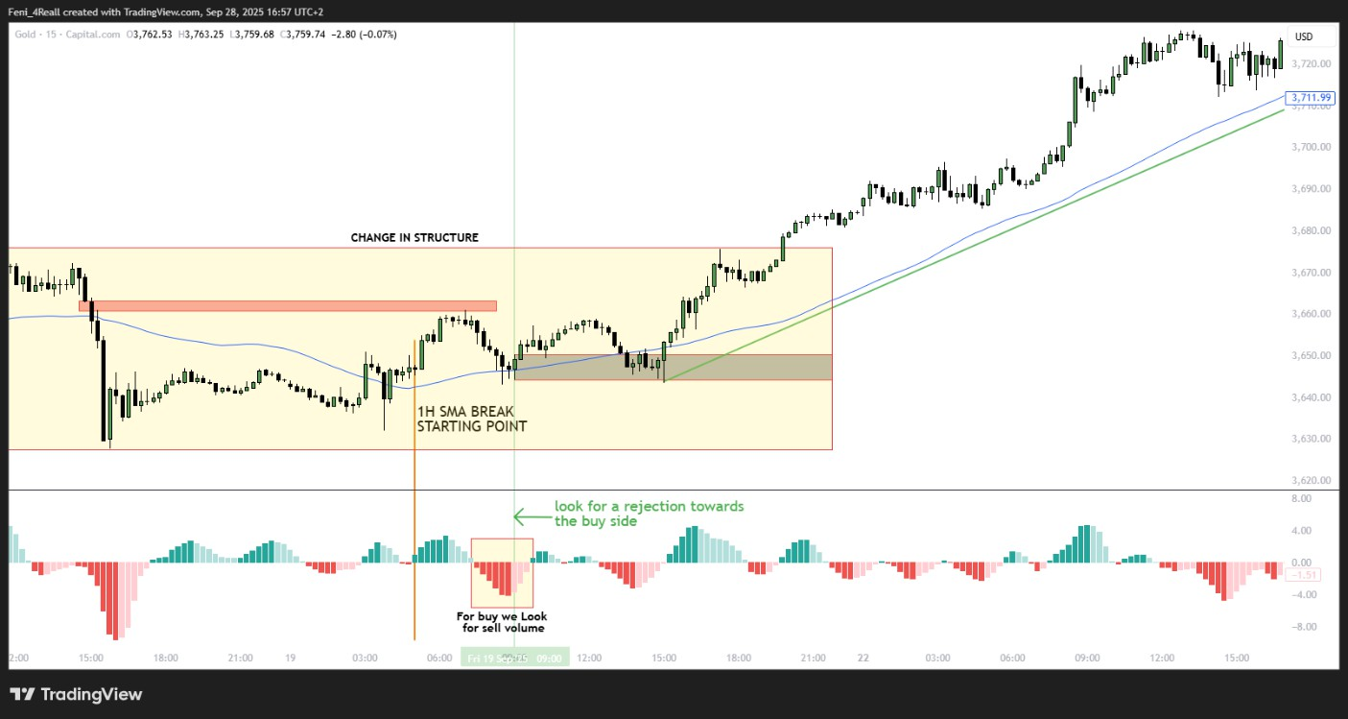

#### Buy Setups (H1 trend up, price above SMA):

* + Bullish engulfing candle
  + Hammer / Pin bar with rejection
  + Inside bar breakout to the upside

#### Sell Setups (H1 trend down, price below SMA):

* + Bearish engulfing candle
  + Shooting star / Pin bar rejection
  + Inside bar breakout to the downside

#### Entry Rule:

* + **Enter after M15 candle closes in trend direction** at Label A zone.

#### Step 5 – Stop-Loss Placement

* + Place **SL just beyond recent M15 swing low/high**:
    - Buy → below nearest M15 low inside Label A zone
    - Sell → above nearest M15 high inside Label A zone

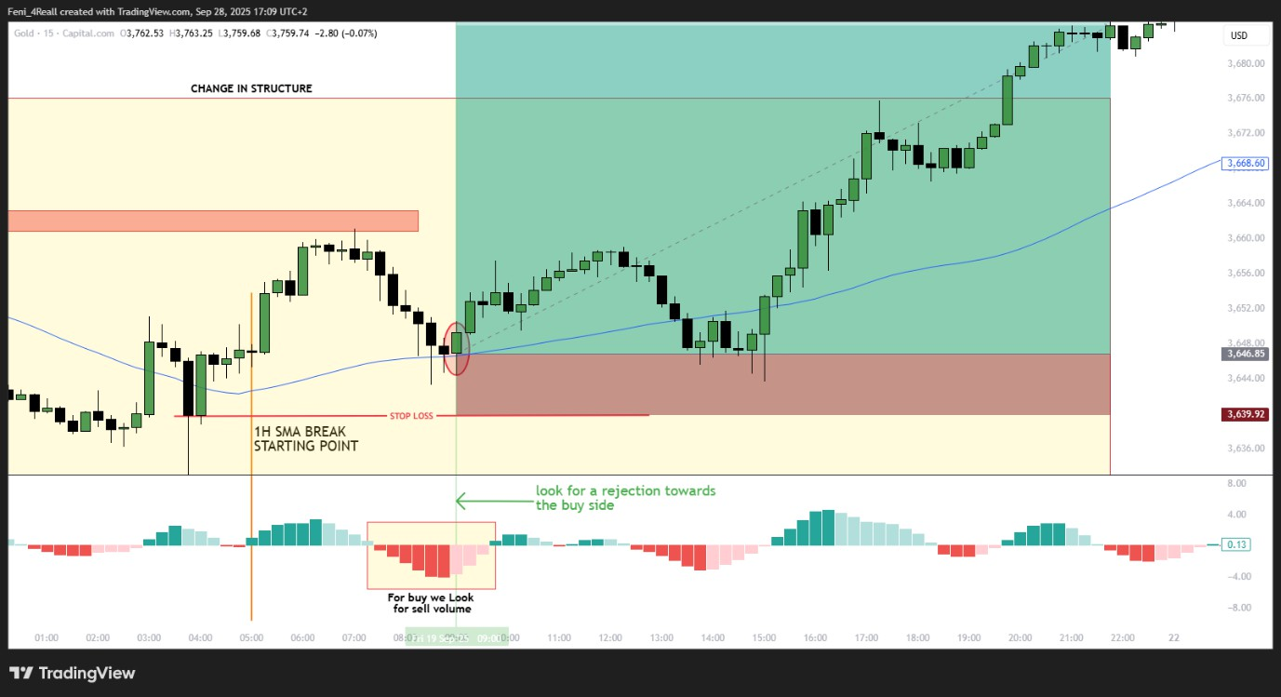

* + Ensures **tight risk control** while allowing the trade to breathe.

#### Step 6 – Take-Profit (TP) Placement

* + TP can be based on:

1. Previous H1 swing highs/lows
2. Trend continuation zones
3. UNIT TREND CHANGES

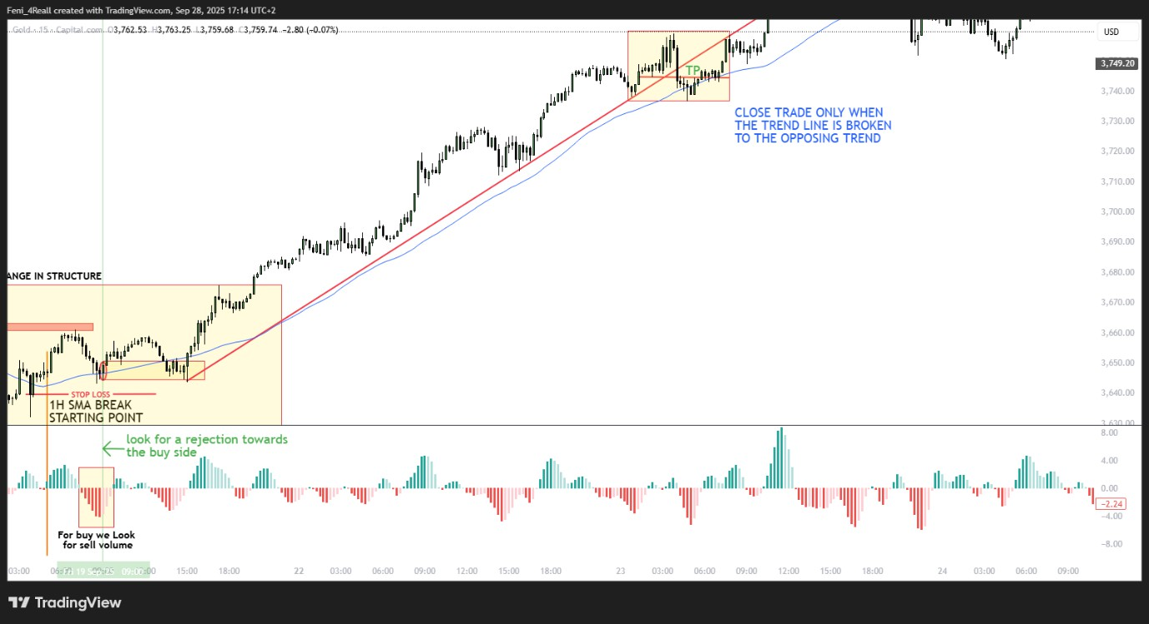

**Optional:** Partial TP at first support/resistance level, move SL to breakeven after partial exit.

#### Step 7 – Trade Management

1. Monitor **Label B (trend line)** – if broken, exit immediately.
2. Optionally scale out partial profits at intermediate zones.
3. Trail SL if trend continues strongly in your direction.

#### Step 8 – Summary – Full Flow

1. **H1 SMA Check:** Confirm trend using Label C (50 SMA).
2. **Identify Label A Zone:** Price approaches H1 SMA.
3. **Draw Label B:** Trend line validation.
4. **Switch to M15:** Look for **entry confirmation patterns** in trend direction.
5. **Enter Trade:** After M15 candle closes in confirmation.
6. **Set SL s TP:** According to M15 swings C H1 trend levels.
7. **Manage Trade:** Monitor trend line, move SL, and take profits strategically.



NO TRADE

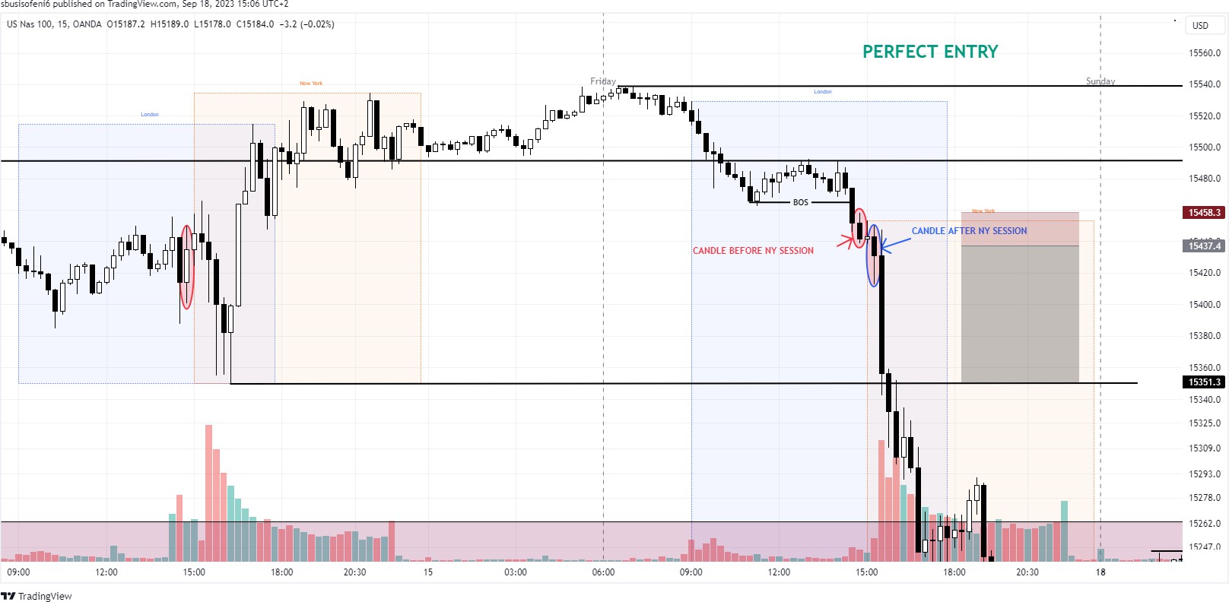

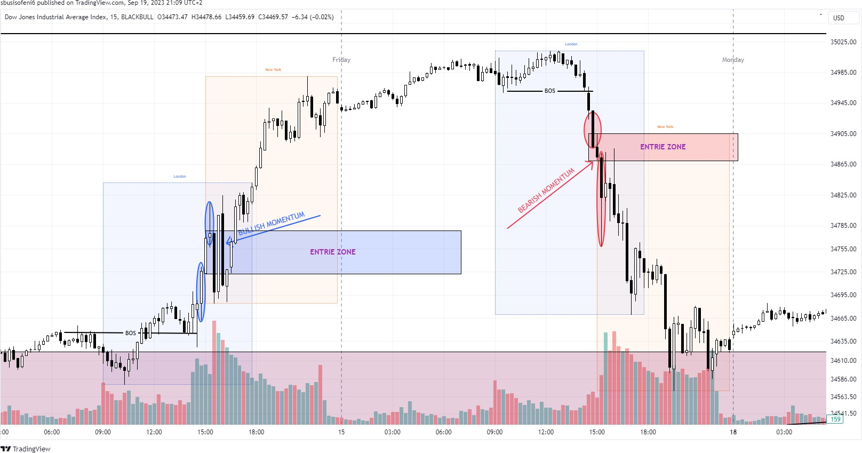

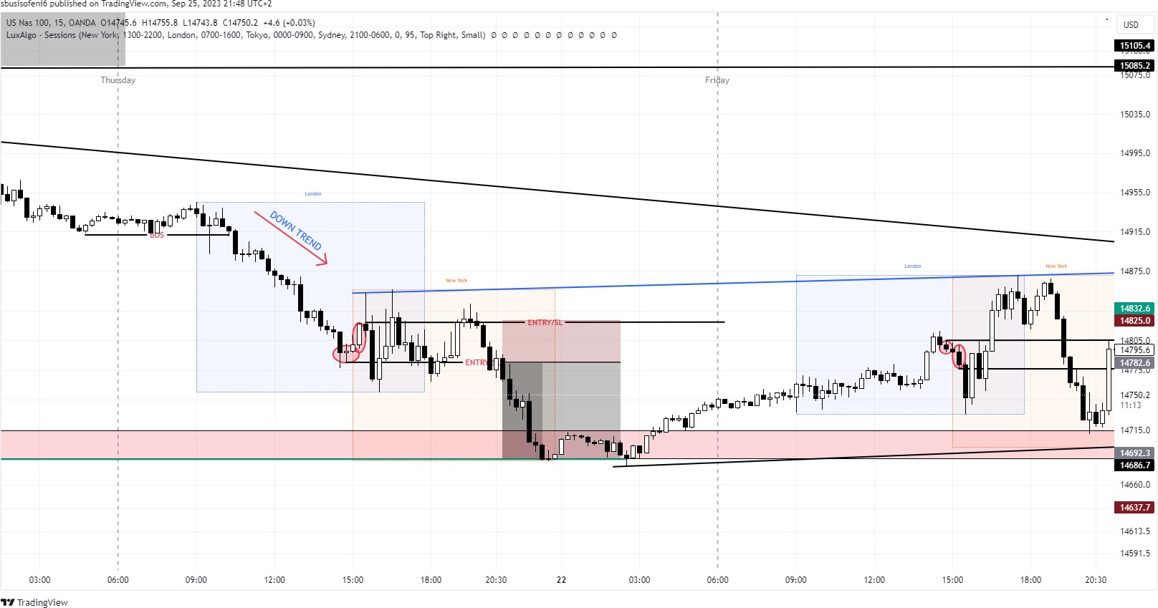

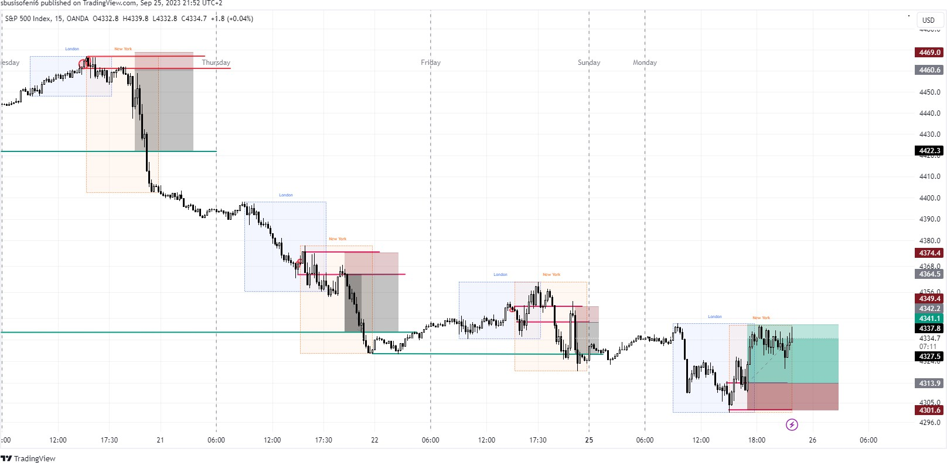

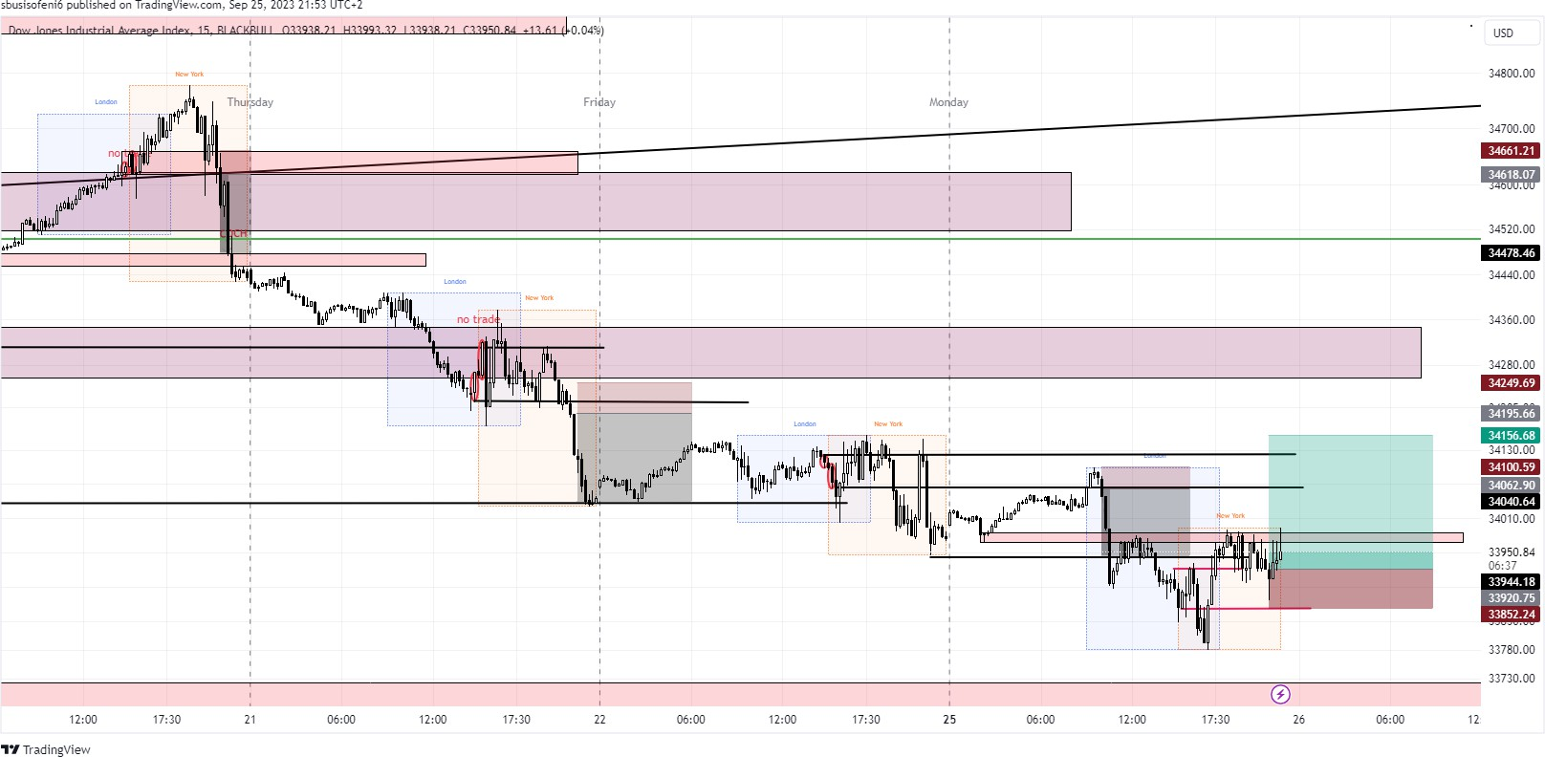

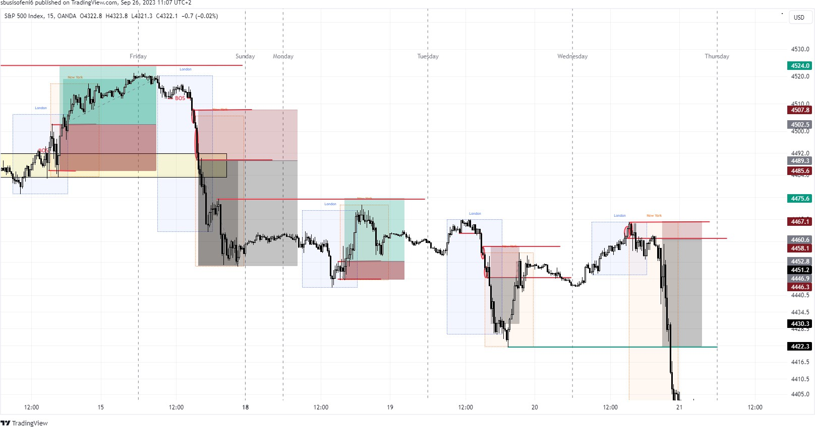

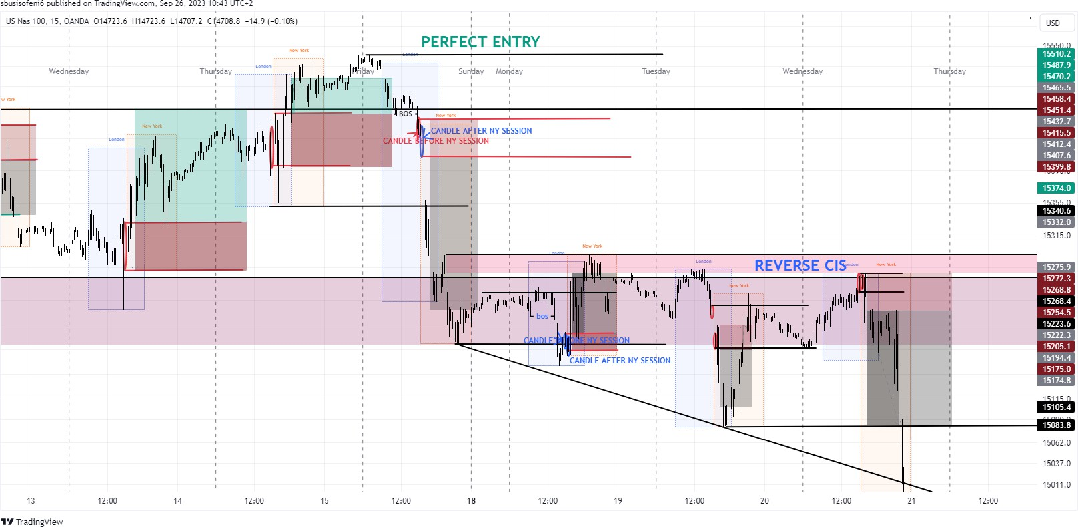

1. **Pairs: You're focusing on the US 30, US 100, and US 500, which are indices representing the Dow Jones Industrial Average, Nasdaq 100, and S&P 500, respectively.**
2. **Time Frame: You're using a 15-minute time frame for your analysis.**
3. **London Session: You're looking for a BOS (Breakout Setup) or COCH (Continuation of the Current High/Low) during the London session. This is a common approach as London is one of the major forex trading sessions and often sees increased volatility.**
4. **Identify Pre-NY Session Candle: Before the New York session, you're identifying a specific candle and placing horizontal lines for entry and stop loss. This is likely a candle pattern or a specific price level you're watching.**
5. **Identify Post-NY Session Candle: After the New York session, you're doing the same, identifying a candle and setting entry and stop loss levels.**
6. **Take Profits: You plan to take profits at the previous session's low if you're in a sell trade or at the previous session's high if it's a buy trade. This approach utilizes support and resistance levels.**
   * **NyuPIP (Feni4Real) Strategy Onboarding Document**

## Strategy Overview

**Name:** NyuPIP (Feni4Real)

**Symbol:** XAUUSD (Gold Spot)

**Strategy Code:** NYUPIP_XAU

**Category:** Standalone — Auto-trading

**Author Reference:** Adapted from Feni4Real’s “Ultimate Trading Blueprint”

**Session Focus:** London & New York

**Timeframes Used:** H1 (Trend filtering), M15 (Entry confirmation)

## Core Logic

**A. 1HSMA (1-Hour Simple Moving Average Strategy)** Goal: Follow the higher timeframe trend.

* 1. Identify trend using 50 SMA (H1).
  2. Mark SMA interaction zone.
  3. Draw trend validation line.
  4. Drop to M15 for confirmation (bullish/bearish patterns).
  5. Enter on M15 close confirmation.

**Stop-Loss:** Beyond latest M15 swing.

**Take-Profit:** Previous H1 swing or key zone.

**B. CIS (Change in Session Strategy)**

Goal: Capture volatility between London–NY transitions.

**Buy:** 14:45 bullish  entry 15:15 close  SL = 14:45 open  TP = prev NY high.

**Sell:** 14:45 bearish  entry 15:15 close  SL = 14:45 open  TP = prev NY low.

## Risk & Trade Management

* Risk per Trade: 1–2% of equity
* Max Concurrent Trades: 2
* Move SL to BE once 50% TP distance achieved
* Hard Stop: No trading during high-impact news
* Auto Disable if daily loss > 5%

## Automation Behavior

Mode: Fully automated

Active Hours: 08:00–18:00 SAST

Conditions: Volatility > avg 14-day ATR, SMA valid, CIS active Disable if volatility < 30% or trend invalidated

## System Integration

| Parameter | Value |

|------------| |

| Strategy Name | NyuPIP (Feni4Real) |

| Code | NYUPIP_XAU |

| Category | Standalone |

| Trading Mode | Auto |

| Symbol | XAUUSD |

| Entry Timeframes | H1, M15 |

| Indicators | SMA(50), RSI (optional) |

| Session Focus | London / New York |

| Logging | Enabled |

## Psychological Notes

* Trade the structure, not emotion
* No manual override during drawdown
* Accept invalidations immediately
* Review after every 20 trades minimum

## Summary

The NyuPIP (Feni4Real) strategy merges structured trend alignment (1HSMA) with precise session timing (CIS) to exploit high-probability gold moves under automated control. Designed for consistency, discipline, and precision.